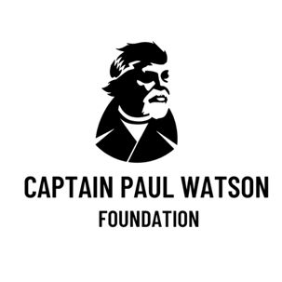

**Danish Parliament Confirms Faroe Islands Tip-off Led to Paul Watson's Arrest**

*Local authorities in the whaling archipelago alerted the Danish Justice Ministry*

*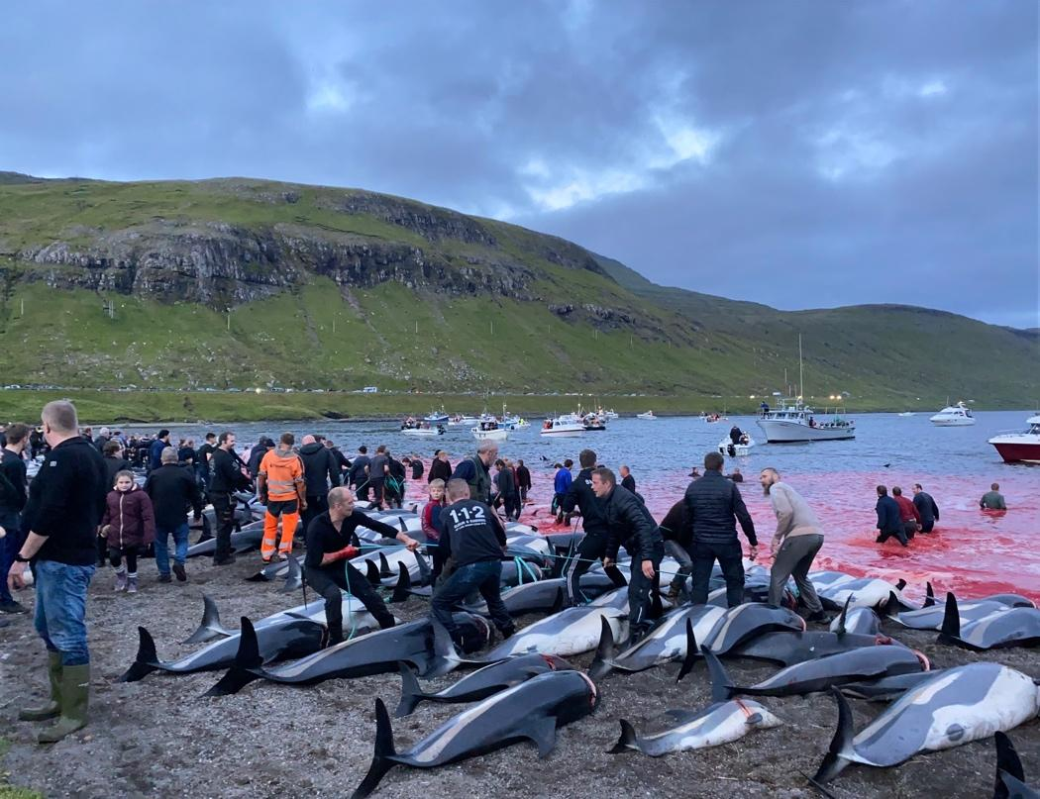F*

*Faroe Islands. Photo credit : CPWF UK / PALLI JUSTESEN*

**Nuuk, Greenland, 14 September 2024** – In a significant development, the Danish Parliament has responded to an inquiry confirming that a police tip-off from the Faroe Islands, a self-governing archipelago of the Kingdom of Denmark, alerted the Danish Ministry of Justice and Greenlandic authorities to the arrival of Captain Paul Watson’s flagship the *JOHN PAUL DE JORIA* to Greenland on its way to stop a Japanese factory whaling ship, and pushed for his detention.

This revelation sheds light on the underlying motivations behind Denmark's compliance with Japan's international arrest warrant, and the heavy-handed nature of Watson’s arrest by Danish Police flown into Greenland to board the vessel.

“*With the Faroe Islands now implicated in Captain Paul Watson's arrest in Greenland, this incident will only intensify the global spotlight on the atrocities occurring in the Faroe Islands, namely the controversial Grindadráp*” stated Omar Todd, CEO of CPWF.

The Faroe Islands are infamous for their cruel dolphin hunts known as the ‘grindadráp’ in Faroese. This barbaric practice involves the chasing and killing of an average of 1,100 dolphins each year, primarily long-finned pilot whales (a species of dolphin) and Atlantic white-sided dolphins. The killing of small cetaceans, and their harassment by boat, is illegal in Denmark, the European Union and many other countries around the world and that is why the Faroese grindadráp draws global condemnation from politicians, conservationists, the media and the general public.  
  
*“Since the early 1980’s, Paul Watson has launched many campaigns against the barbaric dolphin hunts and is a thorn in the side of the Faroe Islands. The Captain Paul Watson Foundation UK is in its 9th consecutive year of ‘Operation Bloody Fjords’ exposing over 70 ‘grinds’ to the world - and last year Paul sailed the CPWF flagship ‘John Paul Dejoria’ into Faroese waters to again oppose the hunts, so this revelation of Faroese involvement in demanding Paul’s arrest comes as no surprise”* said Rob Read, COO of CPWF UK.

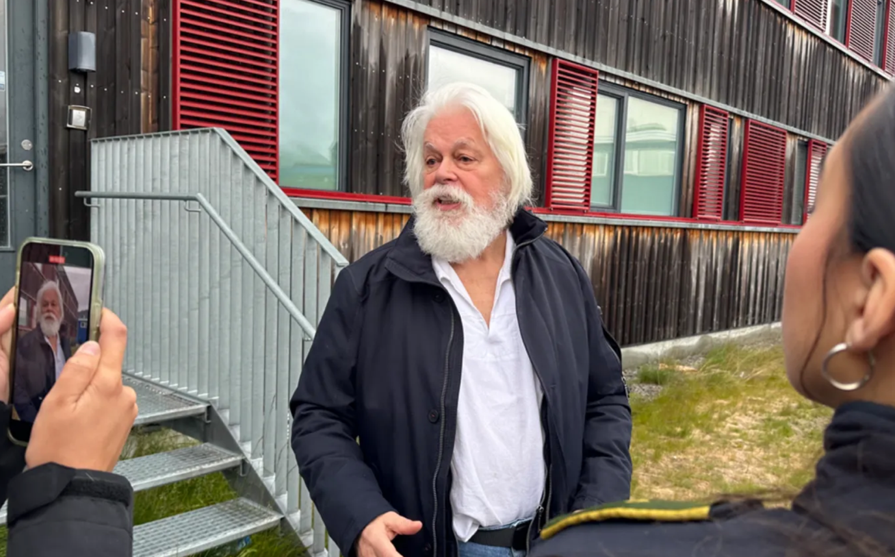*Paul Watson outside court, Nuuk Greenland.*

Renowned environmental hero, Captain Paul Watson, has dedicated over five decades to protecting endangered whales and other marine life, has been held in prison in Greenland since July 21st. when he docked on a routine fuel stop. His detention follows the enforcement of a politically motivated Interpol Red Notice lodged by Japan over 12 years ago, for direct action activism while protecting whales inside a globally recognized sanctuary.

“*While it is normal for ships to announce their arrival days ahead when calling into a foreign port, in this case, a busybody from the Faroe Islands Police, spurred on by Japan’s desire to nab Paul, took a serious interest in this and made a concerted effort to tip off the Danish Ministry of Justice after tracking the ship since its departure from UK, causing Danish Police to make local inquiries, confirm the arrival of the vessel and allowing time for a swat team to orchestrate an ambush worthy of an international fugitive*” stated Locky MacLean, Head of Ship Operations. CPWF is calling upon Denmark to release Paul Watson immediately and reject Japan’s politically motivated extradition request.

---ENDS---

[Photos & Images](https://www.dropbox.com/scl/fo/ccfnac7v54zyzjqvcwshu/AABSwyWPJ9uyq2E7-9eo3Bg?rlkey=jfxmbjnlxx29iu9g5pksnbsmv&st=e3b8mce4&dl=0)

For media inquiries, please contact:

Campaign Director : Captain Locky MacLean : [locky@neptunes.navy](mailto:locky@neptunes.navy)

CEO : Omar Todd : [ceo@neptunes.navy](mailto:ceo@neptunes.navy)

Media : Charlotte Kanter : [media@paulwatsonfoundation.com](mailto:media@paulwatsonfoundation.com)

Grindadráp / Faroe Islands inquiry : [faroes@paulwatsonfoundation.uk](mailto:faroes@paulwatsonfoundation.uk)

**About the Captain Paul Watson Foundation** The Captain Paul Watson Foundation is dedicated to the conservation of marine wildlife and the protection of the ocean ecosystem. Founded by Captain Paul Watson, the organization works tirelessly to combat illegal fishing, whaling, and other threats to marine life through direct action, advocacy, and public education.